**PRACTICAL NO. 5**

**Aim: Exploring GitHub to learn features such as**

* 1. **How to create repositories on GitHub.**
  2. **How source code can be uploaded/downloaded from repositories.**
  3. **Making code commits in repositories.**

**Theory:**

**Introduction to GitHub**

GitHub is a web-based [hosting service](https://en.wikipedia.org/wiki/Internet_hosting_service) for [version control](https://en.wikipedia.org/wiki/Version_control) using [git](https://en.wikipedia.org/wiki/Git). It is mostly used for [computer code](https://en.wikipedia.org/wiki/Source_code). It offers all of the [distributed version control](https://en.wikipedia.org/wiki/Distributed_version_control) and [source code management](https://en.wikipedia.org/wiki/Source_code_management) (SCM) functionality of Git as well as adding its own features. It provides [access control](https://en.wikipedia.org/wiki/Access_control) and several collaboration features such as [bug tracking](https://en.wikipedia.org/wiki/Bug_tracking_system), [feature requests](https://en.wikipedia.org/wiki/Software_feature), [task management](https://en.wikipedia.org/wiki/Task_management), and [wikis](https://en.wikipedia.org/wiki/Wiki) for every project.

GitHub offers plans for both private repositories and free accounts which are commonly used to host [open-source](https://en.wikipedia.org/wiki/Open-source) software projects. As of April 2017, GitHub reports having almost 20 million users and 57 million [repositories](https://en.wikipedia.org/wiki/Repository_(version_control)), making it the largest host of [source code](https://en.wikipedia.org/wiki/Source_code)in the world.

GitHub is mostly used for code.

In addition to [source code](https://en.wikipedia.org/wiki/Source_code), GitHub supports the following formats and features:

* Documentation, including automatically rendered [README](https://en.wikipedia.org/wiki/README) files in a variety of [Markdown](https://en.wikipedia.org/wiki/Markdown)-like file formats
* [Issue tracking](https://en.wikipedia.org/wiki/Issue_tracking) (including feature requests) with labels, milestones, assignees and a search engine
* [Pull requests](https://en.wikipedia.org/wiki/Pull_request) with code review and comments
* Commits history
* Graphs: pulse, contributors, commits, code frequency, punch card, network, members
* Integrations Directory
* Email notifications
* Option to subscribe someone to notifications by [@ mentioning](https://en.wikipedia.org/wiki/Mention_(blogging)) them.
* [GitHub Pages](https://en.wikipedia.org/wiki/GitHub_Pages): small websites can be hosted from public repositories on GitHub. The URL format is https://*username*.github.io.
* Nested [task-lists](https://en.wikipedia.org/wiki/To_do_list) within files
* PDF document viewer

**Steps to create repository in GitHub:**

1. Sign up GitHub.

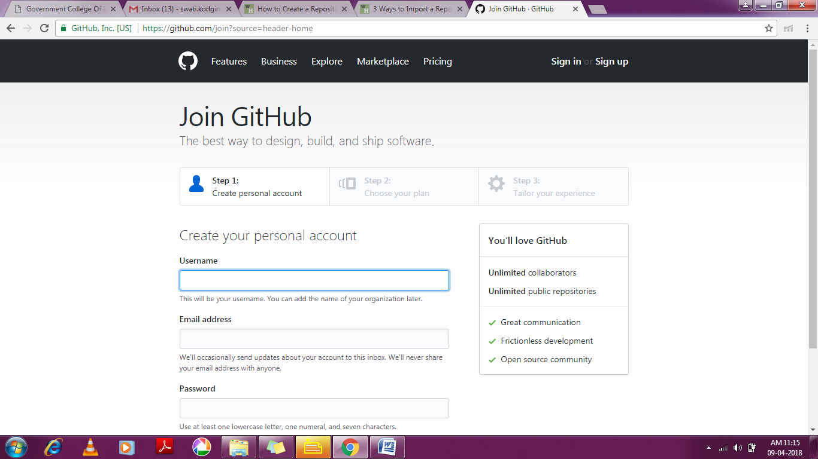

1. Go to the [GitHub login page](https://github.com/login) and log in using the email and password associated with your account.

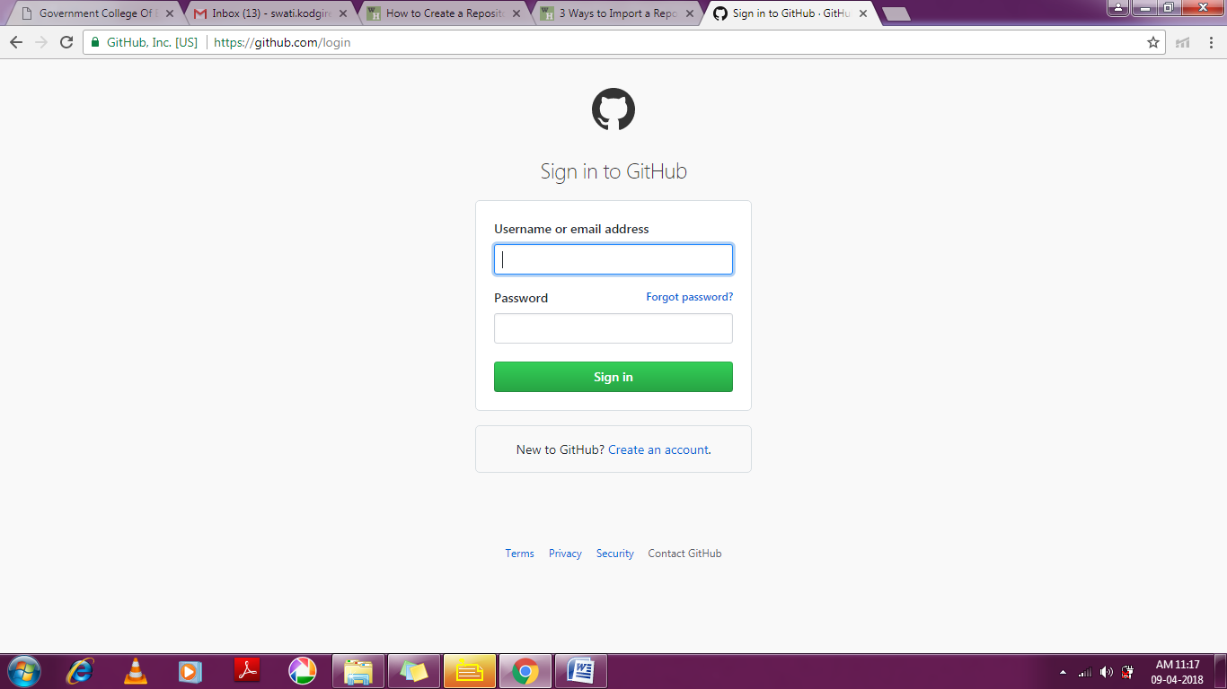

1. Click Start a project and fill up the repository details. Enter a project name, and an optional description and homepage URL. Select the “Public” option to create a free public repo that anyone can access, or select the “Private” option to upgrade to a paid account and create a private repository. Click the “Create Repository” button to create a new repository.

|  |  |  |
| --- | --- | --- |
|  |  |  |

**Steps to upload/download files/folders to the created repository and make commits**.

* 1. To upload the file click on ‘Upload files’.

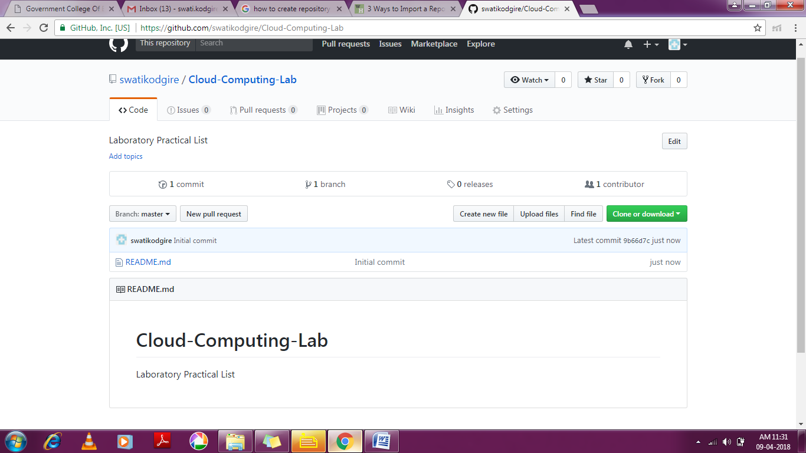

* 1. After the file/s is uploaded click on commit changes to save the file.

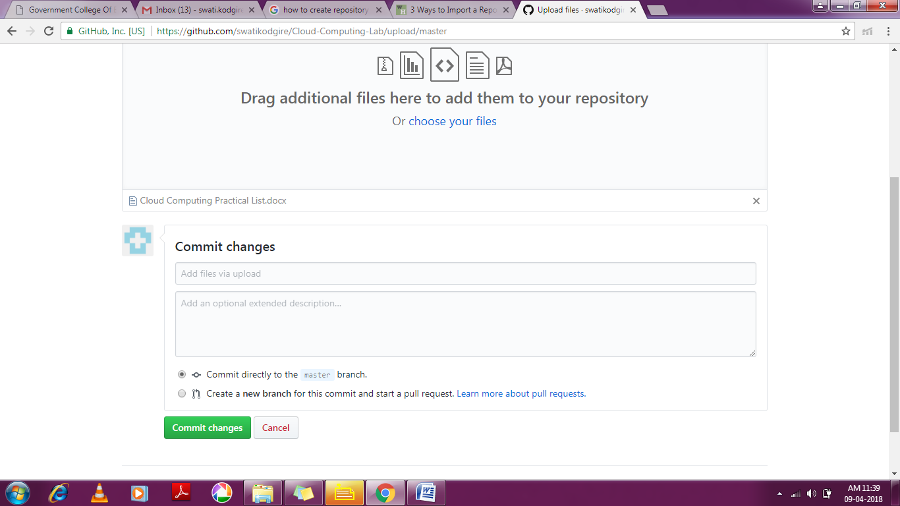

* 1. The other users of github can commit changes to our repository, by downloading the files, editing, modifying the content and again need to upload the modified version of the same.

**Conclusion: Thus, we have studied the procedure to sign up the GitHub and upload files to the repository and make the commits.**